**Changing the placement of the youtube report button**

**Epic - Report Fraudulent Videos**

**I. User stories**

1. As a user, I want to see the report button on the right of the save button so that I can report fraudulent videos quickly

Acceptance Criteria -

1. The report button should be displayed on the right side of the save button
2. The report button should not be visible on the hamburger menu
3. The report button should be hoverable
4. The report button should follow the standard theme and color scheme of the screen
5. The placement of the report button next to the save button should not impact any other functionality on the screen
6. The help guide has been updated about where to find the report button and how to report videos
7. As a user, I want to report fraudulent videos using the report button so that I can provide details for the report

Acceptance Criteria -

1. The popup screen for reporting reasons should be displayed upon clicking the report button
2. The popup screen for reporting reasons should allow the user to provide a reason for the report and add a video timestamp to report a fraudulent video segment
3. The user should see a confirmation popup of successful report submission on the screen
4. The user should receive an email confirmation of the report submission
5. The user should be able to resume/replay the video after submitting the report
6. Error Handling - The user should be able to see an alert message “reporting process encountered an error! Please send feedback to the youtube team” if the report button does not work or the report workflow breaks before submission

**II. Plan of action**

Based on the available resources, the following plan of action will be followed

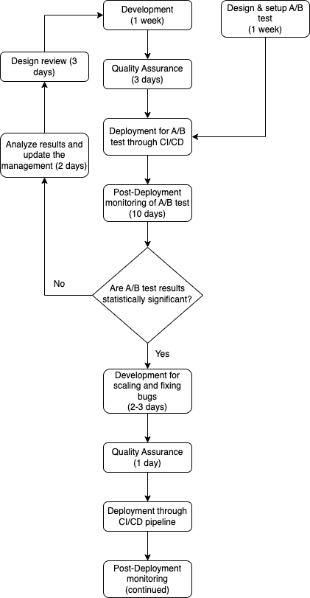

The estimated timeline to deliver this change can be found [here](https://utkarshaworkspace.atlassian.net/jira/software/projects/YVWP/boards/3/roadmap)

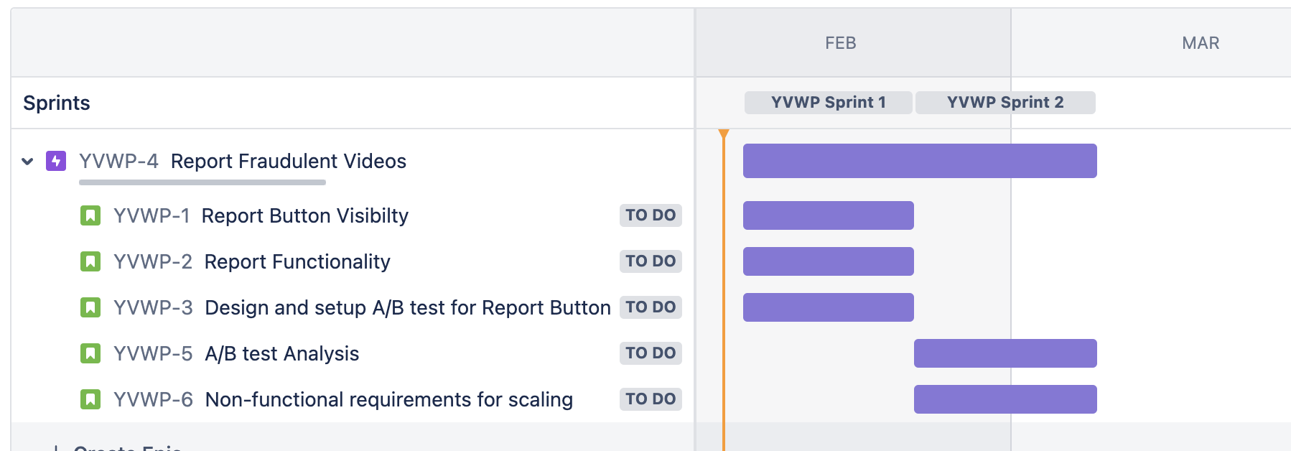

**III. Success criteria for the project**

1. Focus Metric: The number of fraudulent videos being reported should increase
2. Support Metrics:

1. The total number of users using the report button to report fraudulent videos should increase

2. The average number of reports per fraudulent video should increase

3. The number of support tickets citing users not being able to report fraudulent videos should reduce

4. The number of support tickets with tags like fraudulent videos, reports, misinformation, etc. should reduce

5. The time required to find the report button and report the video should decrease

1. The change should not negatively affect the usage statistics of other functionalities on the screen
2. The change should be implemented within the estimated timeframe and budget
3. The code deployed should follow the best practices and meet the company standards and SLA requirements

**IV. Future Enhancements to reduce fraudulent videos**

1. **Voice of the viewer program**: Select and invite trusted users, verify the users, and incentivize them to find and report fraudulent videos as soon as possible. Such videos can be prioritized for review and youtube admins can take necessary action against these fraudulent videos. Having a trusted group of users to report videos can expedite the video moderation process and reduce the risk of false reporting.
2. **Reporting Process Enhancement**: Employ a strong video moderation team to handle large volumes of reports and ensure timely action against fraudulent videos.
3. **Automated fraud detection**: Use machine learning algorithms to automatically detect and flag fraudulent videos based on past youtube videos and reports data. Use techniques like user sentiment analysis of the comment section and image processing for videos to report fraudulent videos.
4. **Video Authentication**: Implement strict guardrails to ensure that fraudulent videos are not uploaded by any user such as checking for any phishing links and URL redirects in the description, verifying the account’s authenticity, and monitoring the videos as soon as they are uploaded.
5. **Third-party collaboration**: Source data from third-party fact-checking organizations and social media platforms to quickly identify fraudulent videos.

**Appendix A [Assumptions]**

**Key Assumptions:**

1. The wireframes are for the Youtube live stream web application version and the scope of implementation is limited to the Youtube live stream web application. The requirements will change and scale if the scope extends to Android, iOS, etc.
2. The team follows a 2-week Agile sprint with 1 QA, 2 developers, 1 UX designer, 1 data analyst, and 1 product manager.

**Appendix B [A/B test design]**

**Purpose of the study**: To analyze if the replacement of the report button from the hamburger menu to the screen (right of the save button) helps the users find the report button easily and increase the number of reports on fraudulent videos.

**Causal question**: What is the effect of moving the report button from the hamburger menu to the right of the save button on the number of reports on fraudulent videos?

**Experimental Setup**:

A sample group of users will be randomly selected from the existing user base. The group will be split into two groups using random selection. These users will be shown the same set of fraudulent videos on youtube

For the regression equation -

Y= ɑ + βX + 𝜖

Outcome variable (Y) = Number of reports for fraudulent videos

Treatment group = People who will be using the new version of the Youtube screen (report button to the right of save button)

Control group = People who will be using the old version of the Youtube screen (report button in the hamburger menu)

To obtain better results we will use techniques like linear panel models with control variables and time dummies, instrumental variables, and propensity score matching to find the approximate causal effect.

**Result:**

If the p-value of the regression model appears to be less than 0.05 and the coefficient for X is positive then we can determine that the report button being moved to the screen from the hamburger menu increases the number of reports on fraudulent videos with 95% confidence level. This means that the report button’s visibility on the screen affects the reports on fraudulent videos. Thus, making the report button more noticeable will help reduce the number of fraudulent videos on Youtube.